Who is who?

Town Rector
Revd Melissa Carter

Town priests
Revd Melissa Carter (Charlton and St Andrews Buckland)
Revd Claire Martin (St Martins)
Revd Sebastian Lungberg



Churchwardens
Ms Camilla Otaki (07578220209)



Church Secretary
Vacant

Church Sacristan
Mrs Jackie Cray



Church Hall booking secretary
Ms Camilla Otaki (07578220209)

Dover Deanery Synod reps
Mr Michael Parkinson and Mr Chris Tyler

Christians together in Dover
Mrs Nanette Gleeson & Mrs Sue Jarrold

Christian Aid rep
Mrs Sue Jarrold

Safeguarding and child protection
Mrs Maggie Tyler &
Mrs Sue Jarrold

Church DJ and IT advisor
Mr Richard Harman

THE LINK
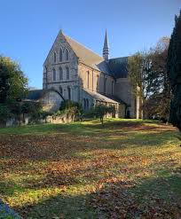

SEPTEMBER-OCTOBER
The Parish Magazine and
pew sheet of
ST PETER & PAUL
CHARLTON CHURCH
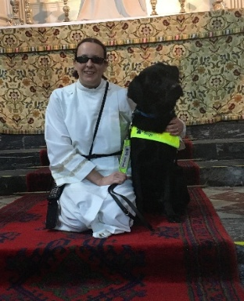
Revd Melissa writes
Learning from Christ’s attitude of grace.

We often talk about people’s attitudes towards this and that. I have been reflecting recently on how our attitudes can sometimes change within a moment and how some are much more fixed. One dictionary definition for attitude is ‘a manner of thinking, feeling or behaving that reflects a state of mind or disposition’. Our attitude towards our beliefs, social justice issues and engagement with different groups are probably quite stable. We might change our attitude towards a group or an issue as we learn more information about it, or as we get to know a group or individuals but what can change quite quickly is when attitude towards our neighbours and loved ones stem from how we are feeling. We all know that other people’s actions have an effect on our attitude towards them but also how we feel in any given moment affects our attitude towards others. I know recently when its been hot and I’m tired I get more grumpy, luckily this usually comes out in me becoming more withdrawn but I am aware it can also make me a little less patient with others than would be my normal disposition.

Reflecting on this and how I can combat it drew me towards thinking about Jesus and how his attitude of Grace shone through in all his encounters with others, even when he was grieving, anxious, busy, frustrated there is a gentleness about him. But Jesus often withdrew to be with the Father and pray.

Time with God is what draws us closer to Christ and it is this healing presence of grace that we need when our attitude towards someone is a bit off kilter. When we encounter God’s Grace we connect with his compassion, kindness, faithfulness and patience which draws us into a feeling of safety, of being seen and being known and this can heal and restore us. So as we follow in Christ’s footsteps, as we join with his body, the church, I pray that we can be still and know God’s grace in our lives and may that grace flow out to others in our words, deeds and actions.

Rev Melissa

BIRTHDAYS
September
12th – Margaret Weeks

October
1st – Joyce Kinden 5th – Joyce Molyneux
7th – Peter Gillham 9th – Lyn Faber
16th – Richard Harman 24th – Karen Gillham

THOSE WHO NEED OUR PRAYERS FOR HEALING AND WHOLENESS
Lynne Bebbington, Kay Dawson, Amy Mears, Thomas Mears, Kim Needy, Derek Robinson, Jessica Taylor, Christine Williams, Albert Wall, Pat Weathered, Barbara Williams, Ian Buckley, Min Gallagher, Jayden (child) (Leukaemia), Michael Nowers, Margaret Nowers, Danny Boyce, Belinda Lovell,Vanessa, Shaun McFarlane, Lyn Faber, Betty Paramor, John Townend, Mollie Simpson, Thomas Green and Lorraine Godley

THOSE WE REMEMBER IN CARE AND NURSING HOMES
Zenia Graves, Toby Marchand and Joyce Molyneux

THOSE RECENTLY DEPARTED
Mark Hanson, Vera Fortune

Mark Hanson recently died having suffered from Dementia for the past 10 years. He hadn’t recognised his family or friends for 3 years. Such was the extent of his illness when seen last his face had the appearance of a 10 year old child. Mark is now at release from this very dilapidating illness safe in the Kingdom of peace reconciled with those that he loved who were waiting for him.
SERVICES / CELEBRANTS FOR SEPT/OCTOBER
September 6th - Creation of Christ - Green
08.00 - No service
09.30 - Revd Richard Woods

September 13th - Trinity 15 - Green
08.00 - Revd Melissa Carter
09.30 - Revd Melissa Carter

September 20th - Trinity 16 - Green
08.00 - Revd Claire Coleman
09.30 - Revd Claire Coleman

September 27th - Trinity 17 / Journey service
08.00 - Revd Melissa Carter
09.30 - Chris leading / Alastair / Richard

October 4th - Trinity 18 - Green
08.00 - Revd Melissa Carter
09.30 - Revd Claire Coleman

October 11th - Harvest -Green
08.00 - Revd Melissa Carter
09.30 - Revd Melissa Carter

October 18th - Trinity 20 -Green
08.00 - Revd Sebastien Lundberg
09.30 - Revd Sebastien Lundberg

October 25th - Trinity 21 / Benefice Farewell service
10.30 - Revd Melissa Carter
Revd Claire Coleman
Revd Sebastien Lundberg

EVENT SPONSORS FOR 2026 SO FAR……..












THANK YOU TO ALL OUR SPONSORS

HYMNS SEPTEMBER / OCTOBER
Sept 6 - 338 - At the name of Jesus
346 - City of God how broad and far
358 - Father of Heaven whose love profound
376 - I heard the voice of Jesus say
372 - He who would valiant be

Sept 13- 354 - Eternal Father strong to save
353 - Dear Lord and Father of mankind
475 - Ye holy angels bright
357 - Father hear the prayer we offer
368 - Guide me O thou great redeemer

Sept 20- 420 - O Jesus I have promised
466 - Thou whose almighty word
495 - God is working his purpose out
288 - God everlasting wonderful and Holy
359 - Fight the good fight

Oct 4 265 - Lord of Beauty
237 - Morning has broken
420 - O Jesus I have promised
276 - Bread of heaven on thee we feed
339- Soldiers of Christ arise

Oct 11 259 - Come ye thankful people come
264 - All things bright and beautiful
285 - For the beauty of the Earth
261 - To thee O Lord our hearts we raise
262 - We plough the fields and scatter

Oct 18 498 - Son of God, eternal saviour
445 - Rock of ages, cleft for me
434 - Oft in danger oft in woe
282 - Faithful shepherd fee me
417 - O God our help in ages past

* VERSES WILL NOT BE SUNG
HYMNS ARE SOMETIMES CHANGED. NOT GUILTY…
ANNIVERSARIES FOR SEPTEMBER
Sep 1st: Norman Smith; Richard Mansfield; Carole Wilkinson
Sep 2nd: Margaret Nicholass
Sep 3rd: George Plant; Doreen Marsh
Sep 4th. David Matthews
Sep 5th: Edward Hall; Ruth Caine; Barbara Neill
Sep 6th: Evan Lewis; Victoria Jenkins
Sep 7th: Thomas Harris; Albert Green
Sep 8th: Joseph Newton; Sidney Cook: Colin Slingsby
Sep 9th: Violet Yates; John Underdown
Sep 10th: Bob Holman; Walter Wakefield; Jack Ffinch
Sep 11th: Lilian Marsh; Jean Wells
Sep 12th: Frederick Belsey; John Cray; Nellie Holbourn; Bennee Cox
Sep 13th: Jessie Blundell
Sep 14th: Harry Wrigley
Sep 15th: Grace Terry: Catherine Lewis; Eric Buckman
Sep 16th: Clara Linge; Winifrid Hoffmeier; Catherine Lewis; John Rowland;
Albert Smith;William Roberts; Cissie King
Sep 17th: Michael Adey; Winifred Kendall; Tom Beer; Eric Waple,
Rudi Mikulas
Sep 18th: Lillian Edwards
Sep 19th: William Brown; Kenneth Healing; Margaret Blundell;
Joy Ovenden; Jon Cox
Sep 20th: Keith Champs; Melvin Finn; Colin Blaskett; Tony Clubb;
Gertrude Ovenden
Sep 21st : Lilian Cloke
Sep 22nd: Diane Hoxton; Florence King; Susan Allen; Victor Wakerell
Sep 23rd: Leah Ross
Sep 24th: Frederick Marsh
Sep 25th: Denis King; Charles Jarvie; Marion Carr
Sep 26th: Mark Embry; Harry Woodridge
Sep 28th: Gwen Billingham; Arnold Moore; May Dyer; Frank R Booth
Sep 29th: Hilda Smith: Revd Paul Christian : Gwenneth M Bell

“They never leave our hearts”
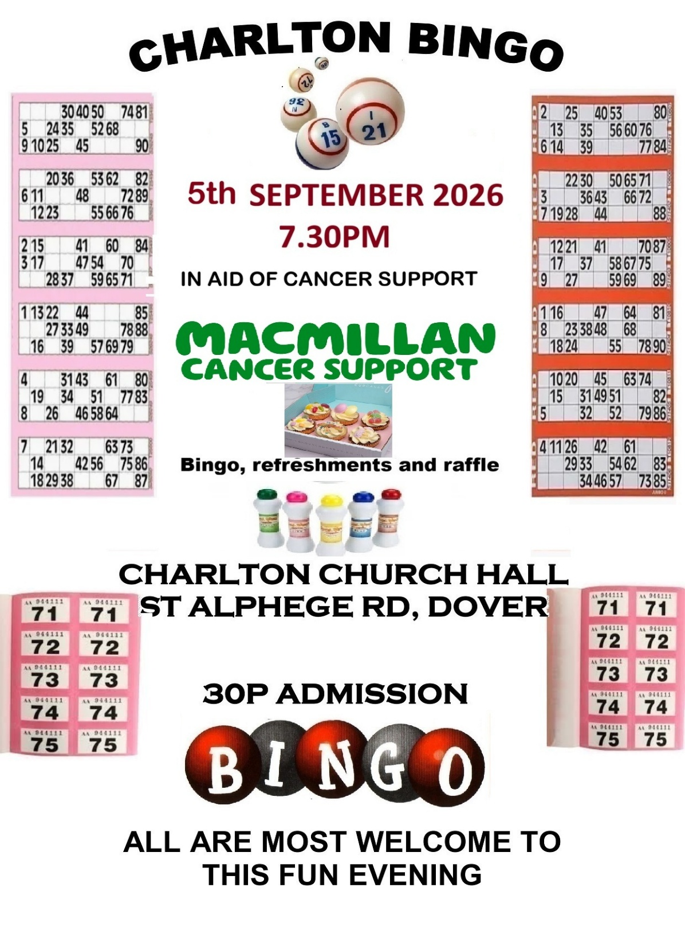
WHAT IS GOING ON?
12th September Macmillan Bingo 7.30pm in hall

20th September Ringlemere (Fine Art) 3pm in Church

2nd October Snowdown/Much Wenlock/Strings
(3 choirs) 6pm in Church

4th October Pet Service 3pm in Church

11th October Harvest Lunch 12noon in Church

18th October Penelope Turner (Fine Art) 3pm in Church

31st October Bingo 7.30pm in Hall

1st November Remembrance evening
Concert & Act of Remembrance
6pm in Church

7th November Train exhibition 10am-4pm Church
Bonfire Bingo 7.30pm in hall

8th November Annual Memorial service 3pm in Church

28th November Charlton Fayre 10am in Church
(with Eclectic Choir)

29th November Bridget Yee (Fine Art) 3pm in Church

13th December Voices of Dover Christmas
Carols tbc

21st December Charlton Pantomime 9.30am in hall

EVENTS ARE SUBJECT TO CHANGES





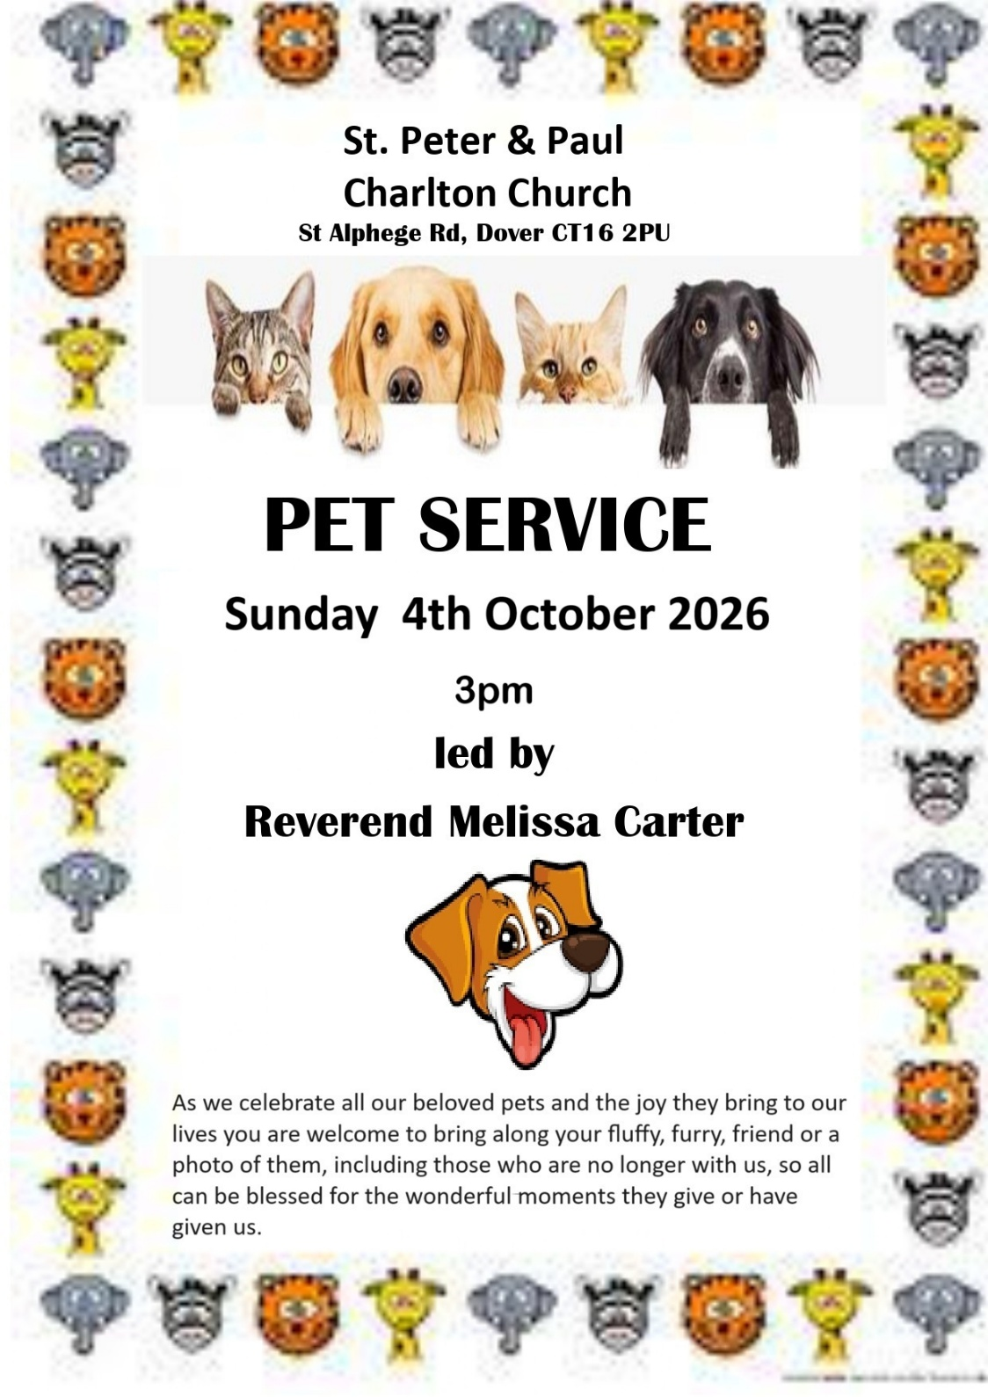
ANNIVERSARIES OCTOBER
Oct 1st: David Bromley; Gertrude Newton; Vi Figg. George Pitts:
Frank Benjamin: Jim Hawkins
Oct 2nd: Eliza Hollway; Kathleen Rusted; Reginald Hogbin; Arthur O’Brian
Oct 3rd: Winifred Reilly
Oct 4th: Mary Johnson; William Clark; George Holliday; Edna Stokell:
Colin Marsh
Oct 5th: Ilma Howard;
Oct 6th: John Howard
Oct 7th: Bert Newby; Rose Matthews
Oct 8th: James Snell (priest)
Oct 9th: Edwin Castle
Oct 10th: Caroline Richards; Rose Buddle; William Jopson; Patricia Corr
Oct 11th: Maddie Marchand
Oct 13th: Jay Brenchley
Oct 14th: Lawrence Adams; Frederick Sangster
Oct 15th: Joseph Butcher; Maude Finnis; Cecil Wyborn
Oct 16th: Frances Blomfield; Thomas Youden; Edward Pope; Gladys Coleman;
David Birch: Ann Yarrow
Oct 17th: Robert Porter; Alan Wanstall
Oct 18th: Phoebe Sanderson; Albert Smith; Helen Graves: Father Colin Johnson
Oct 19th: Albert Topliss, Val Crowley
Oct 20th: Alice Slater
Oct 21st: Ernest Kemp; Thomas Foad; Peggy Davidson: Mollie Greenstreet
Oct 22nd: Richard Pake; Arthur Linscott; Denis Clifford
Oct 23rd : Julia Knighton
Oct 24th: Stephen Terry; Harry Bland; Sybil Collier: Peggy Reader: Bob Healing
Oct 25th: Helen Newby; Arthur Bouxman, Dorothy Russell
Oct 26th: William Embry; Emma Marsh
Oct 27th: Olive Gilchrist; Claude Hatfield: Jean Cox
Oct 28th: Olive Batty; Dilys Wynn; Priscilla Knott
Oct 29th: Ann Fletcher: Elsie Barnes: Robert Manuel
Oct 30th: William Nowers: Barbara Williams
Oct 31st: John Melhuish

" Our loved one's departed are waiting for us to be with them one day"

QUIZ QUESTIONS
1. Who is the current Prime Minister? Andy Burnham correct
2. Captital of Somalia? Mogadishu correct
Then the most difficult one of the lot…..
3. Who is your prayer partner this year??
(Answer from Maggie if unknown or forgotten)

Which disciple is below


Answer
Judus..Is a carrot

(School jokebook)

Maths question : Whats 5 and 2 = ………. 5,000

Why did 3 of some animals get on the Arc ? Noah hadn't been to Specsavers

How did the 3 Wise men find the baby Jesus? They used Star-nav

When the disciple Thomas was a child he sat his exams. When his
parents asked him if he thought he has passed he replied
"I doubt it"

Which Roman leader always had a cold? Julius Sneezer

If Peter "The Rock" had fathered children would they have been pebbles
ROTA FOR READERS ETC
Sept 6th OT - Richard H NT - Paul
Prayers - Richard W

Sept 13th OT - Maggie NT - Nanette
Prayers - Chris

Sept 20th OT - Camilla NT - Sue J
Prayers - Nanette

Sept 27th OT - Chris NT - Richard
Prayers - Alastair

Oct 4th OT - Camilla NT - Jemma
Prayers - Melissa

Oct 11th OT - Michael NT - Jackie
Prayers - Chris

Oct 18th OT - Nanette NT - Maggie
Prayers - Nanette

Oct 25th OT - Camilla NT - Chris
Prayers - Melissa, Seb and Claire

ANY ABOVE COULD BE SUBJECT TO CHANGE FOR
UNSEEN CIRCUMSTANCES


